The unseen tsunami

It was a simple and valid question, asked earnestly by a concerned parent. How effective are the home cryotherapy treatments for warts? But this is a question to which there is no simple and valid answer. No doubt, if I looked hard enough, I would be able to find a study somewhere to give me a framework. However, would that study be of cryotherapy in general practice or dermatology departments or do-this-at-home cryotherapy? Either way, what was the protocol and does that extend into the real-world experience of this treatment? Cryotherapy, in my hands, hurts. It is hard to hurt someone you love – how long do they freeze the wart for? Do they repeat the cycle? Do they repeat the cycle once, twice? Do they allow a thaw in between? Who paid for the research? What was the end point? One week? Two? A month? More? Finally, I was the worst person to ask how effective this treatment is, because the only time I register that a patient has used it is when it has failed and they are presenting for advice about how to manage their warts. So, my natural assumption is that it is not very successful. However, I don’t see the ones which worked, so I have no idea how effective or otherwise this treatment actually is. Finally, given enough time, most warts will go, regardless of the treatments we do or do not try. You cannot do a double blinded, placebo controlled randomised trial into cryotherapy! Are we all simply buying time? God heals and the doctors take the credit?

When it comes to home cryotherapy, I confess to having observation bias. I believe this very same bias affects my hospital-based colleagues and impacts upon their assessment of the effectiveness of the community health sector. As a doctor who has studied and worked within the university, hospital and community sectors, I am daily reminded of both my expertise and my limitations. I don’t get everything right. Even if I did, I still can’t control for all the variables such as individual patient variation reflected in
patient preference
patient choice
compliance
economic factors
advice from others
Dr Google
the particulars of the presentation e.g. the intensity of a condition in an individual

So it is that, despite my best efforts, some of the patients I take care of end up in ED or referred to a specialist colleague, sometimes against my better judgement. If this is all you ever see of the work I do, you will assume that it is not very successful. You might even distain my sector and consider us to be inadequate, wondering at why on earth we would waste our years of study to end up a member of this part of the medical profession.

You would be wrong.
You do not know what you do not see.
You do not see the tsunami we hold back, because it never reaches your shores.

One obviously difficult area to accurately measure is the impact of the GP workforce in mental health. Information from the AIHW quotes BEACH survey data, estimating that “only 1 in 6 estimated GP encounters that were mental health-related were billed using the specific MBS item numbers in 2015-2016”. Even allowing for this under-representation, GPs provided more services than other provider types (psychologists, clinical psychologists, psychiatrists, social workers, OTs, RNs).
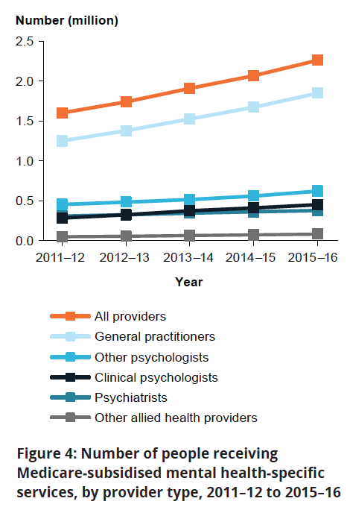

This data represents activity, not outcomes, but how do we assess the latter? Is it possible to measure the impact of the road not taken?

Do any of us know the outcome of our daily intersections with others?

How on earth can we begin to measure the ripple effects of conversations, interventions, education, therapy or medication when there are infinite unknown possibilities that flow from each and every intersection or intervention?

Before you dismiss the impact of the work done in the community sector, which includes friends, family, peers, schools, books, websites, NGOs, allied health professionals, pharmacists, as well as GPs, please pause to consider: is there a tsunami you simply do not see?

Dr Wendy Burton
July 17, 2018

